Independent Programming using Spark

Able to analyze data using RDDS and Data Frames

Creating RDD with parallelize

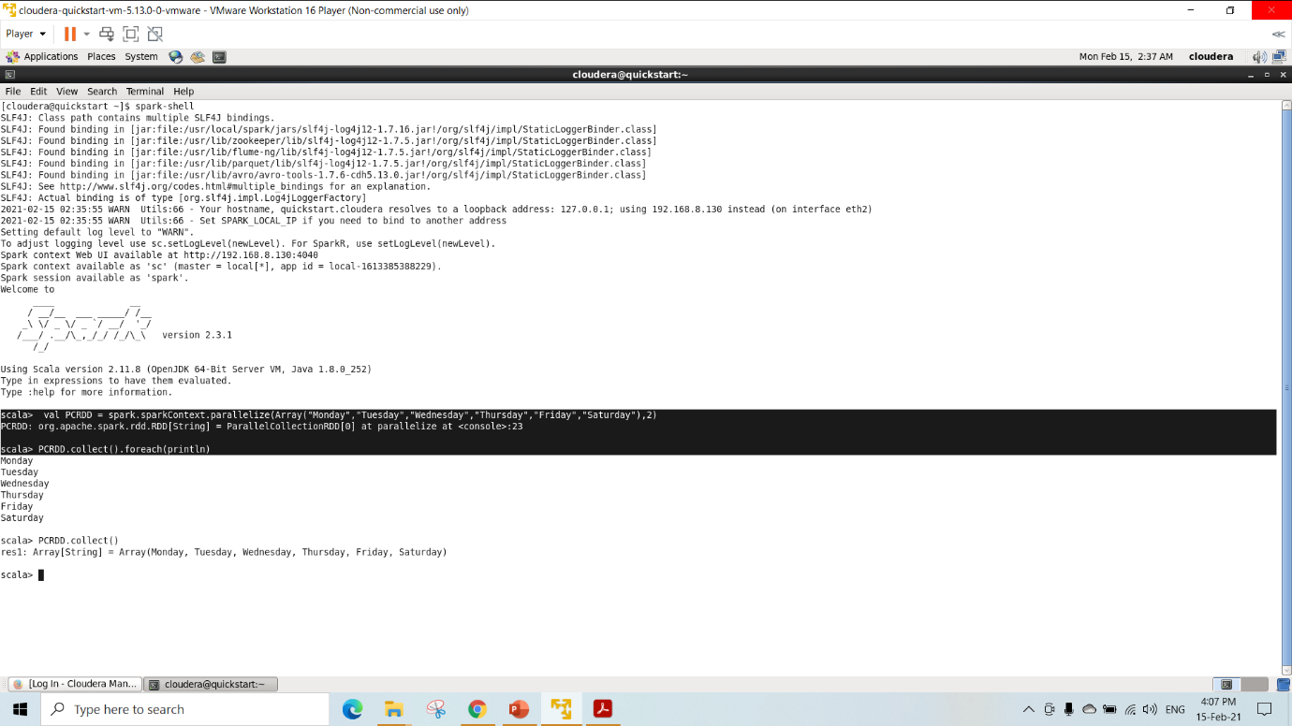

Create RDD from another RDD

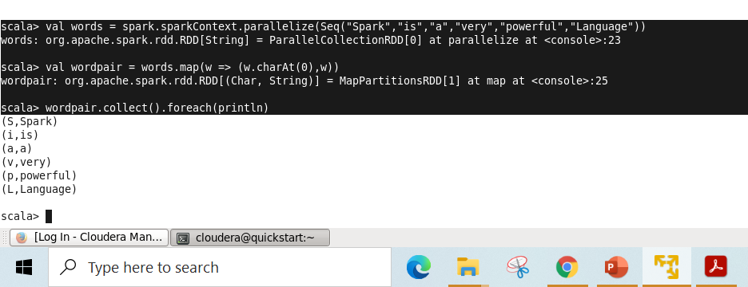

Creating reading and printing schema

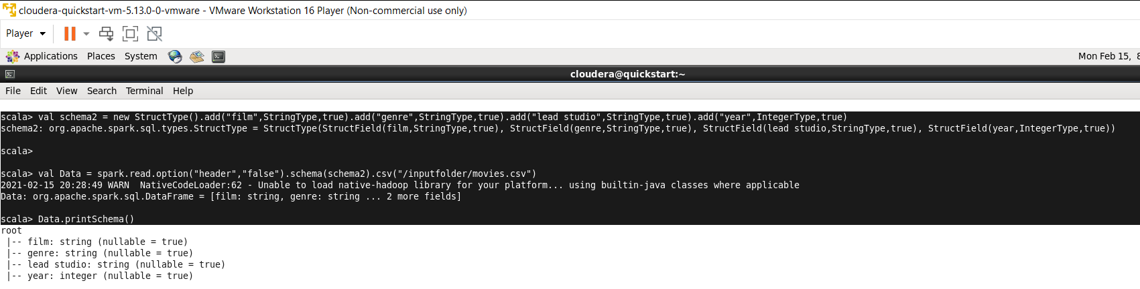

Operations performed on RDD

Actions

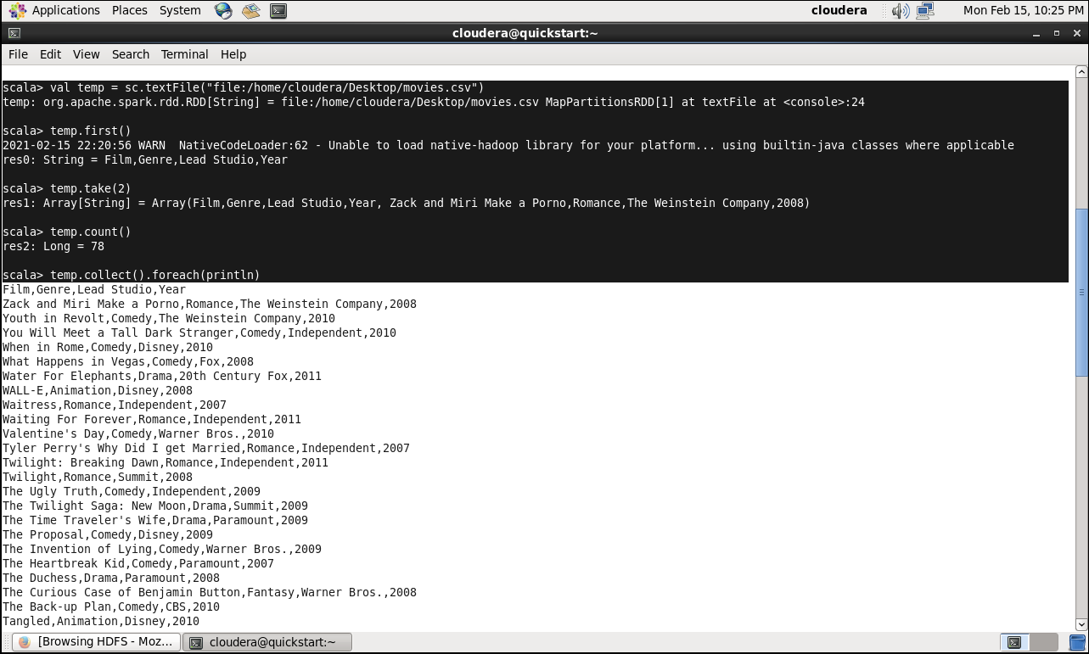

Printing first 5 records

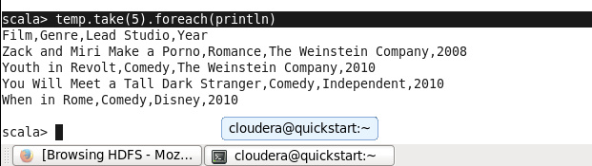

Transformations

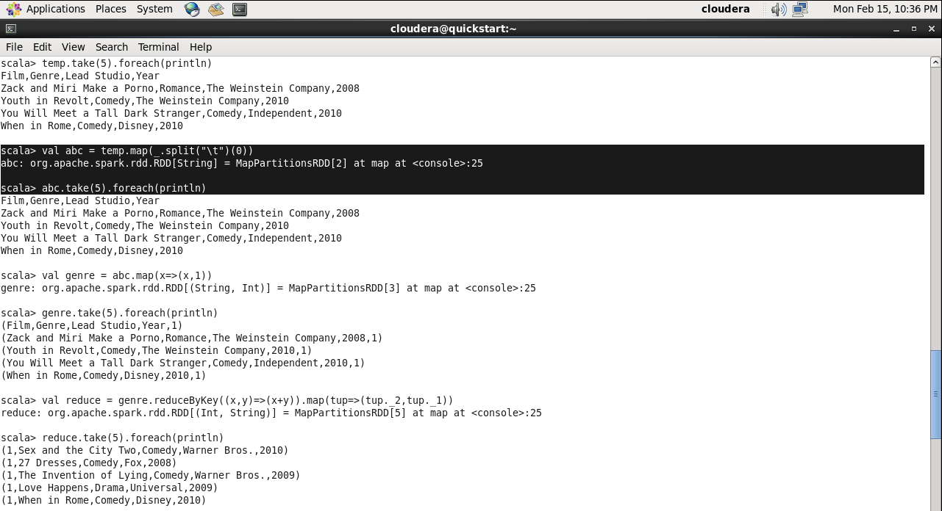

Reduce by key foreach

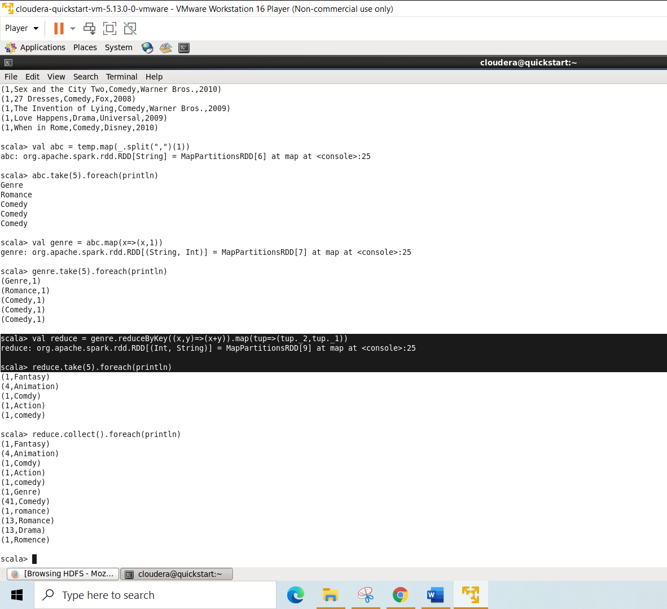

reduceByKey with map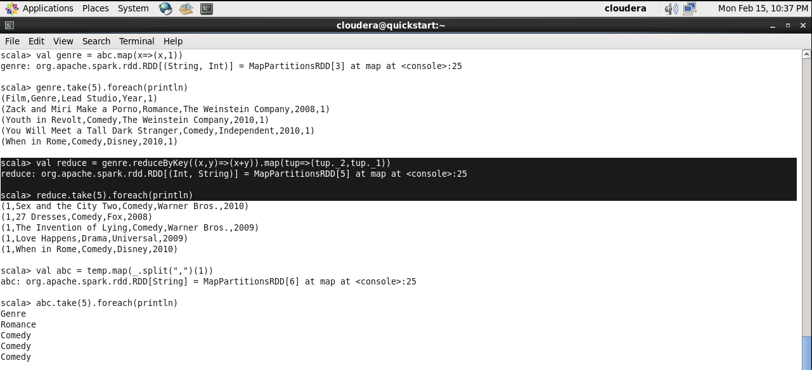

Showing data

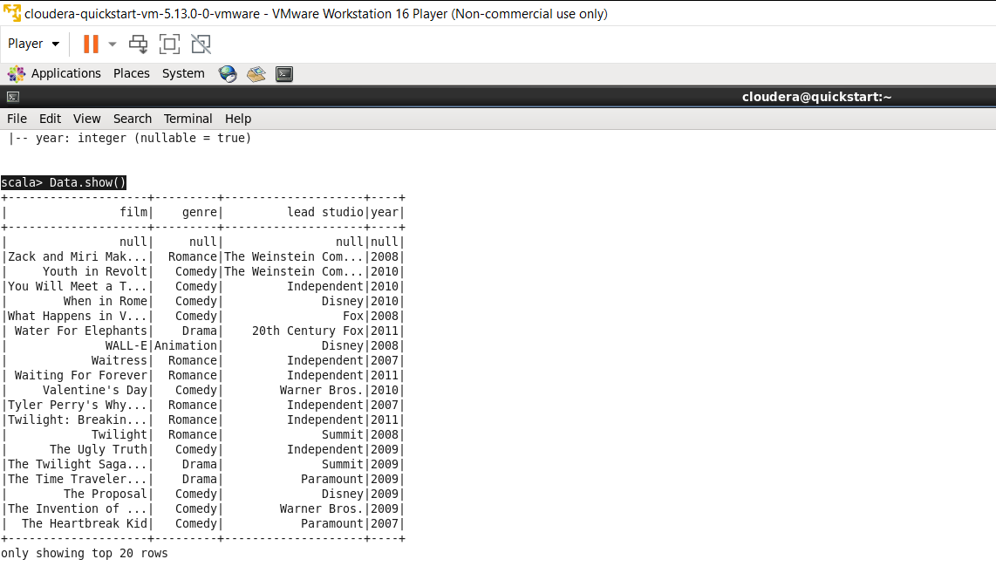

Groupthe dataframe according to the genre and display its count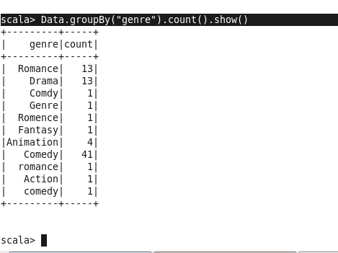

spark-shell command and Importing all packages to run the spark

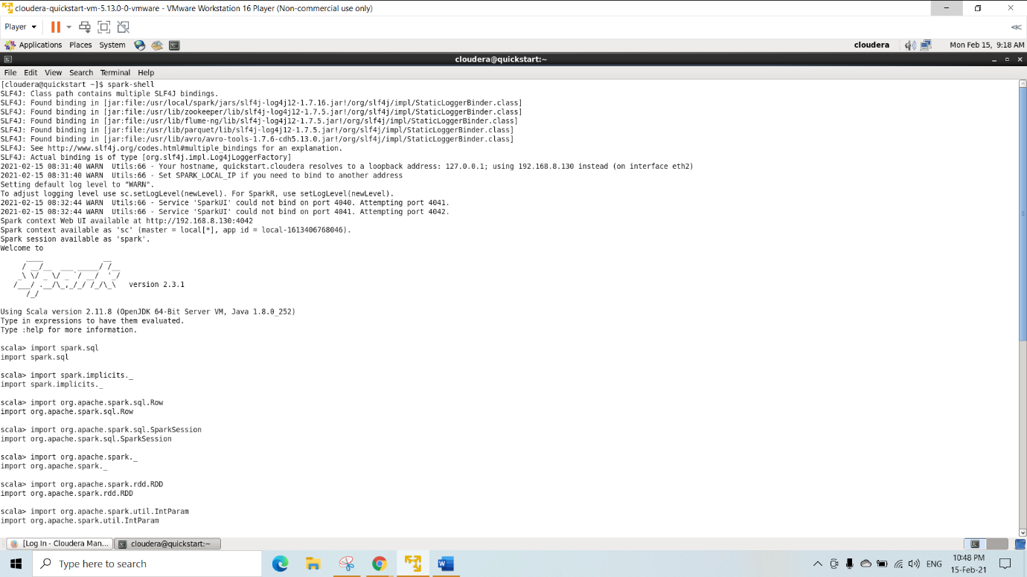

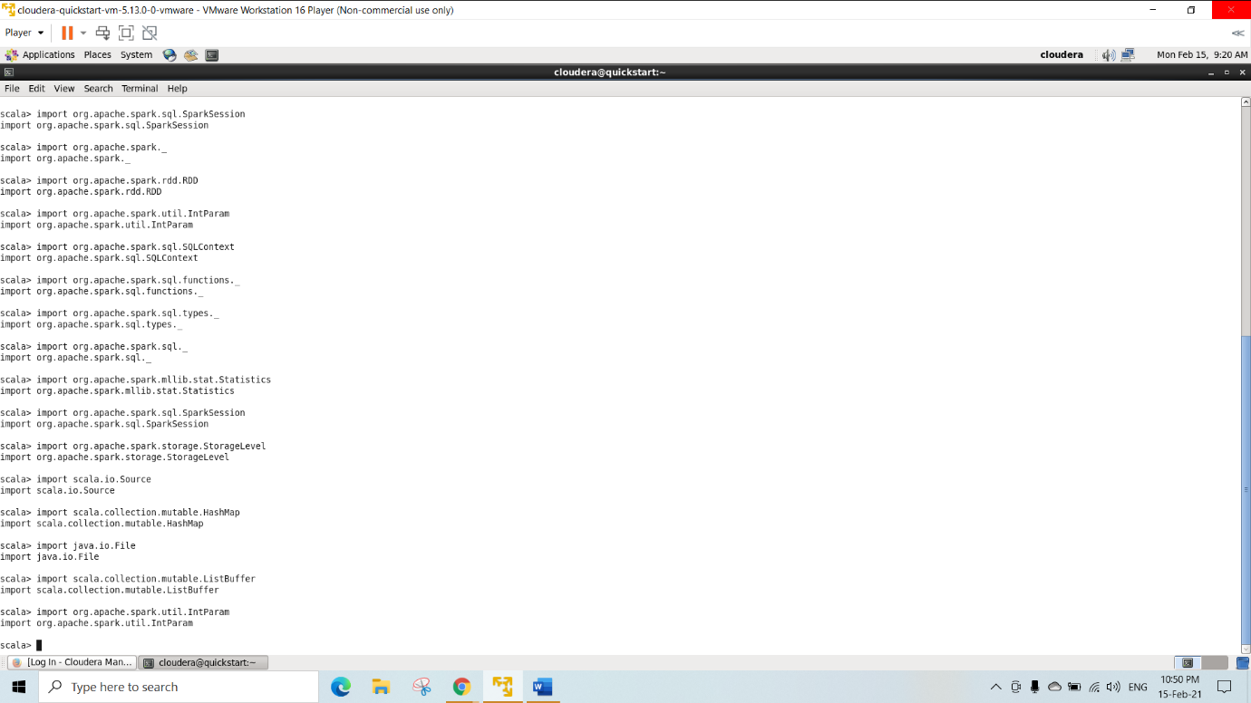

Table creation for joins

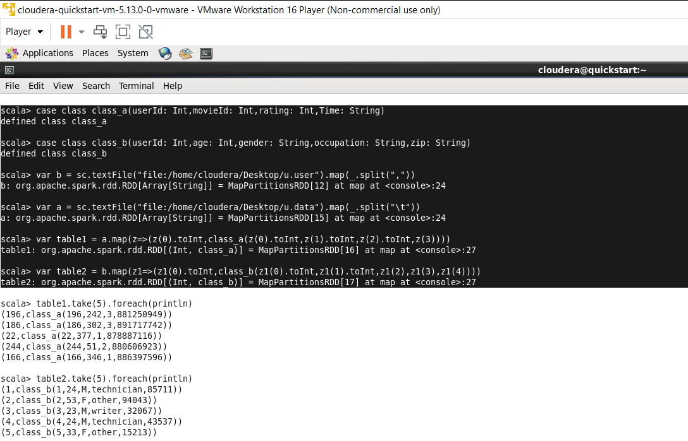

right outer join with output

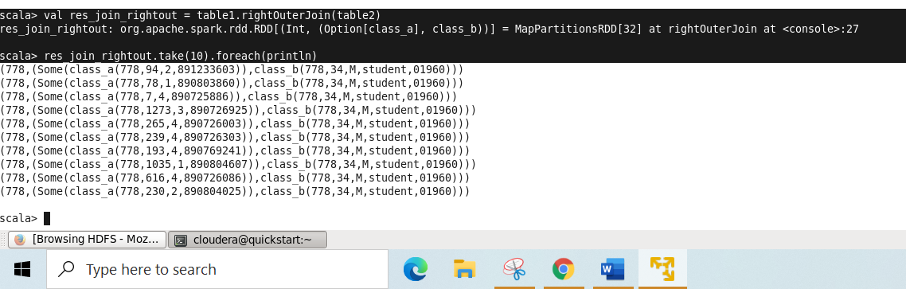

Leftouterjoin with output

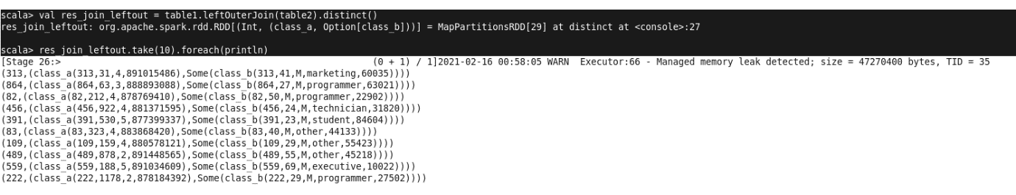Inner or Full join with output

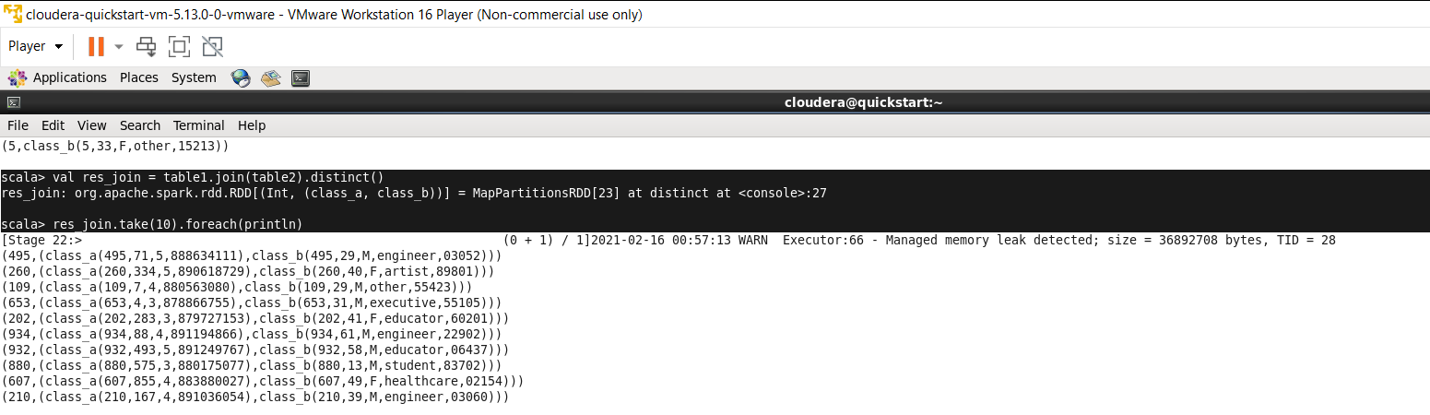

Able to Query data using Spark SQL

Apache sql and creating table(u_data)

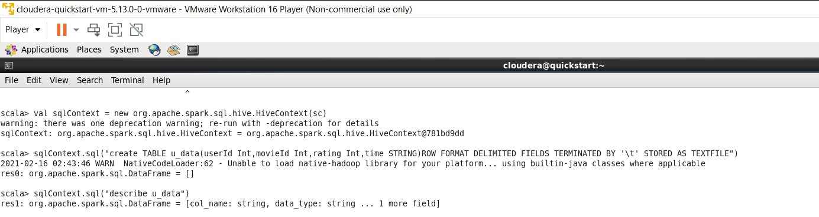

Loading data to the table(put table u.data into testfolder in Hadoop using other terminal)

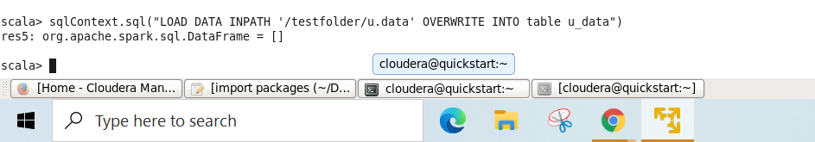

Displaying first 10 rows

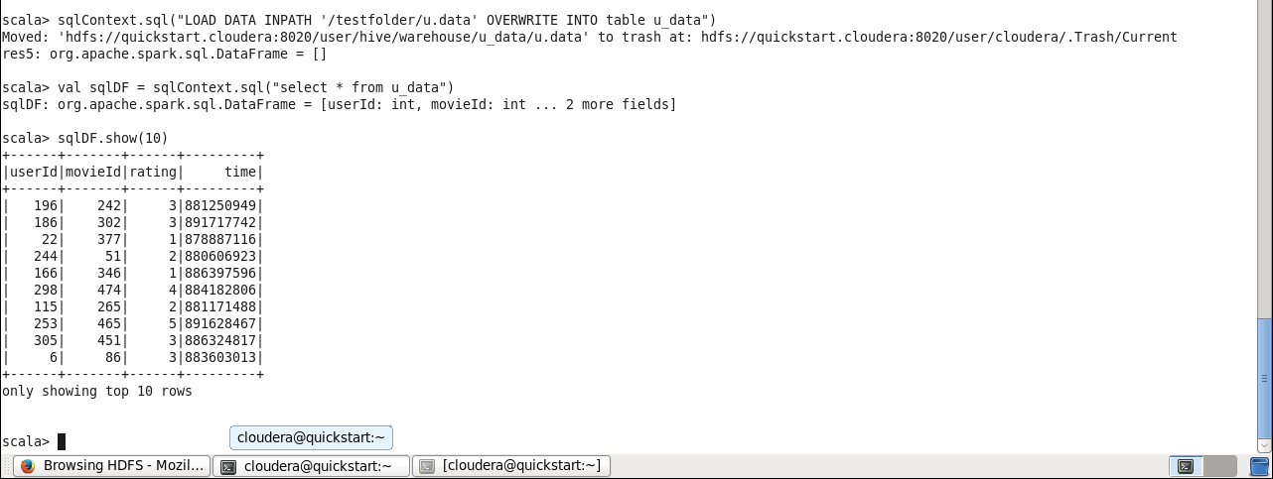

creating temporary view and displaying count of movies watched by each user

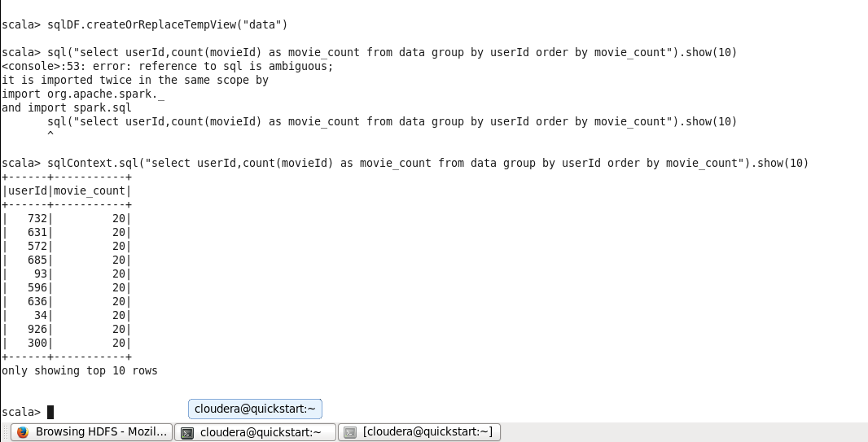

Query to get the count of users who watched particular movie

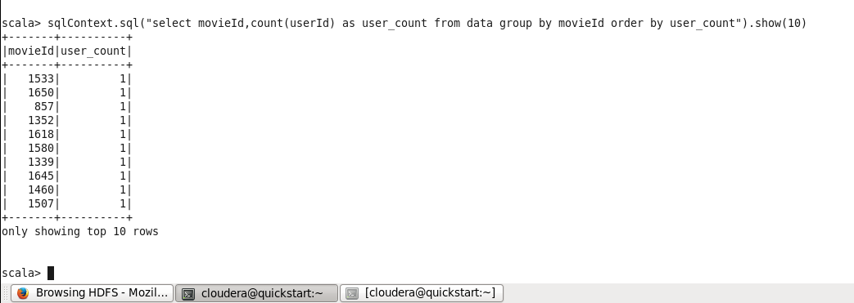

Created table u_user and get the view

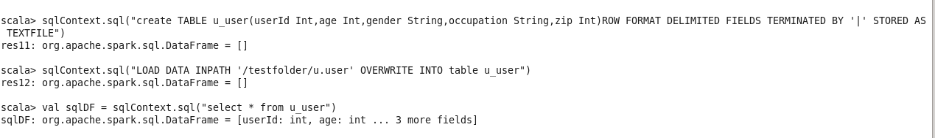

Self Join for u_data table

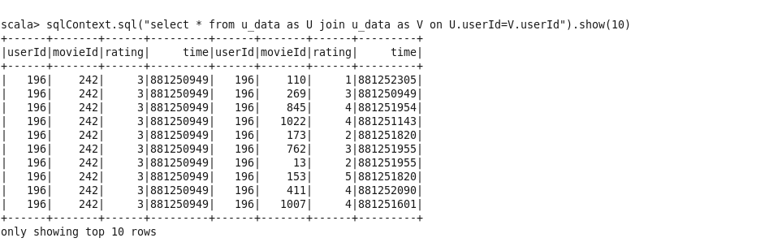

Creating employee sequence and creating schema

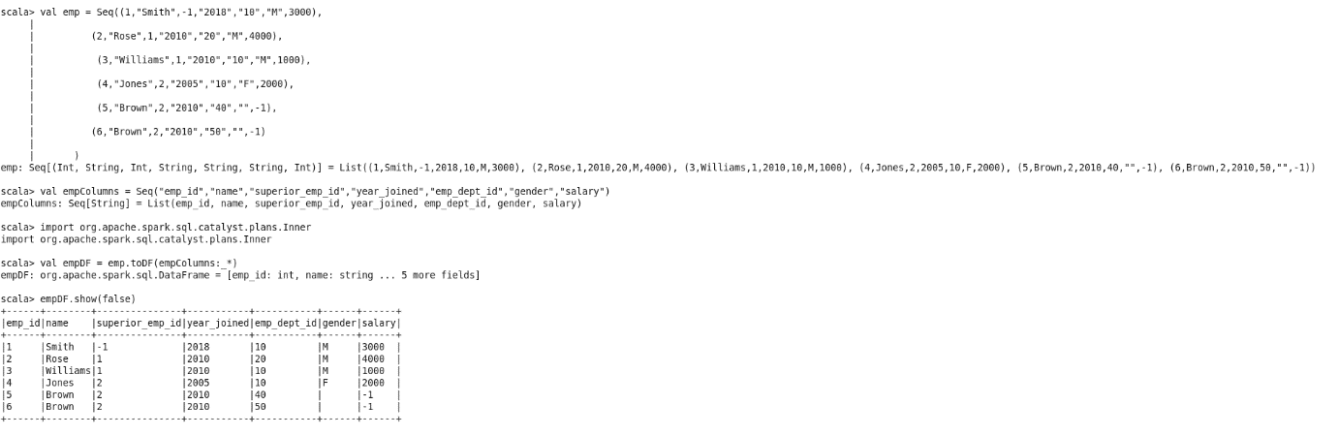

Creating department sequence and creating schema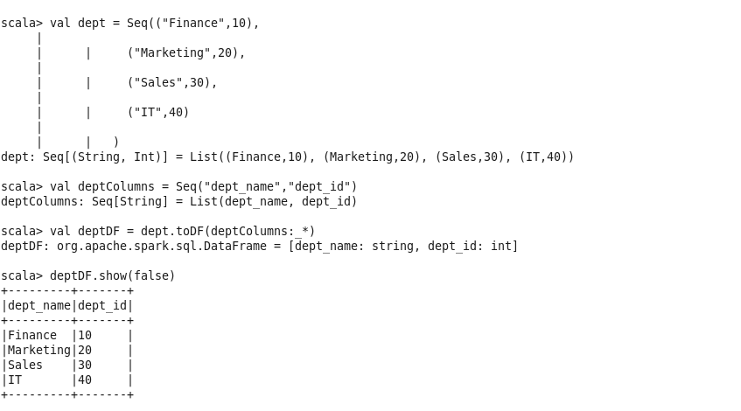

create views

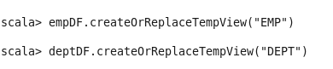

inner joins

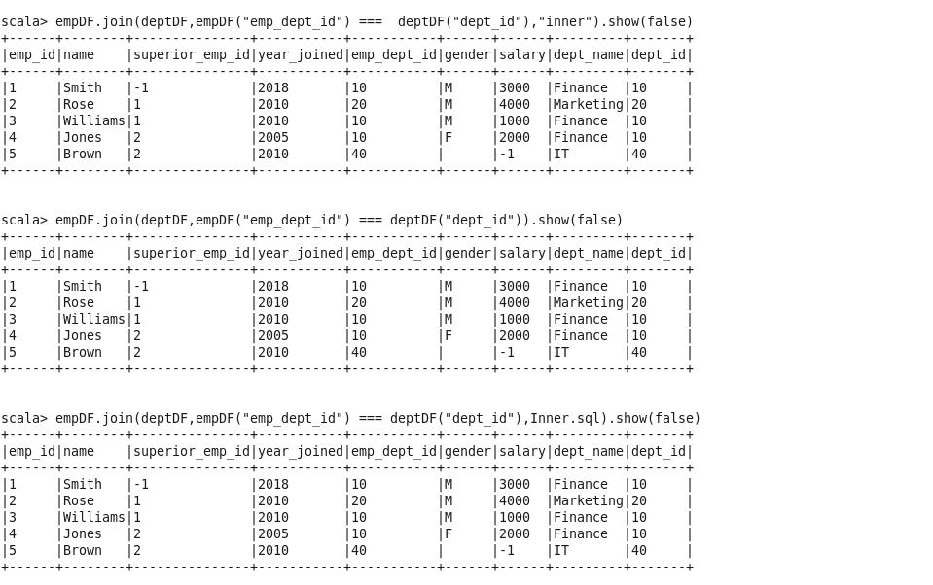

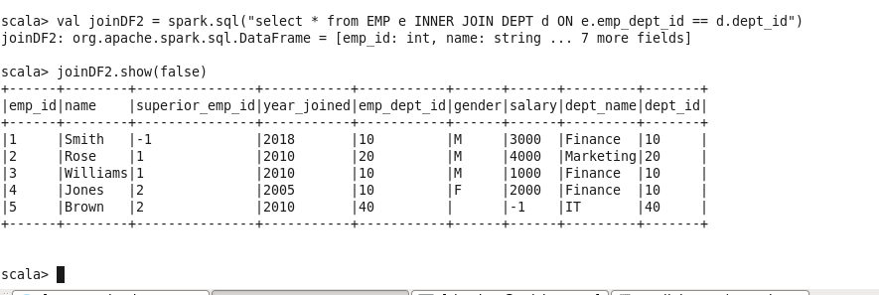outer join

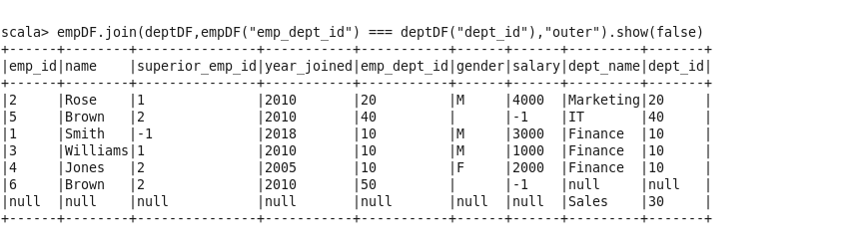

cross join

